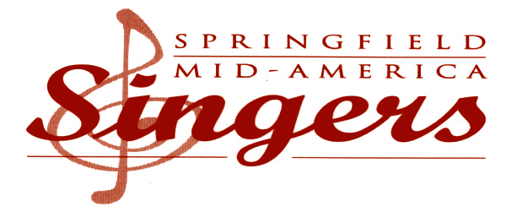

**PROGRAM BOOKLET ADVERTISEMENT CONTRACT**

◆ ◆ ◆

Company Name: Date:

Address:

City: State: ZIP

Telephone: FAX:

Contact Name: E-mail:

◆ ◆ ◆

**ADVERTISEMENT SIZE** (please check)

⬜ Business Card—Eighth-Page (3.5” x 2”) $100

⬜ Quarter-Page **Horizontal** (4.5” x 1.75”) $200

⬜ Quarter-Page **Vertical** (3.75” x 2.25”) $200

⬜ Half-Page **Horizontal** (4.5 x 3.75) $300

⬜ Half-Page **Vertical** (2.25” x 7.5”) $300

⬜ Full-Page (4.5 x 7.5”) $500

**ADVERTISEMENT DESIGN**

⬜ Print my same advertisement from last year (Please attach copy of ad)

⬜ Business card attached (we will resize to fit size selected)

⬜ Camera-ready* artwork attached (we will resize to fit size selected)

⬜ High Resolution PDF supplied and sent to program booklet coordinator (**mark_bowdidge@yahoo.com**)

◆ ◆ ◆

**PAYMENT** (Please make checks payable to “Springfield Mid-America Singers.” ***Please include payment with contract and artwork.***)

Check #: Amount: Date:

Advertiser Signature Advertiser Name (printed)

SMAS Sales Representative:

**All advertisement sales must be submitted by Tuesday, September 27, 2016**

◆ ◆ ◆

*Thank you for supporting Springfield Mid-America Singers!*

*Camera-ready means the ad is usable ***as is*** and does not require cutting, pasting, or typesetting, except as necessary to fit the size selected.

Springfield Mid-America Singers • The Creamery Arts Center • 411 N. Sherman Parkway • Springfield, MO 65802 • 417-863-SING